## VISVESVARAYA TECHNOLOGICAL UNIVERSITY

**“JnanaSangama”, Machhe, Belagavi, Karnataka-590018**



An Internship Report on

## “Used Book Store Application”

*Submitted in partial fulfillment towards Mini-Project Work of V semester of*

### Bachelor of Engineering

in

### CSE (ARTIFICIAL INTELLIGENCE AND MACHINE LEARNING)

Submitted by

#### ANANYA K R

#### (4GW21CI003)

**Under the Guidance of**

**Dr. Manju Prasad B**

Professor & Head



**DEPARTMENT OF CSE (ARTIFICIAL INTELLIGENCE AND MACHINE LEARNING) GSSS INSTITUTE OF ENGINEERING & TECHNOLOGY FOR WOMEN**

(Affiliated to VTU, Belagavi, Approved by AICTE, New Delhi & Govt. of Karnataka)

**(Accredited with A Grade by NAAC)**

K.R.S ROAD, METAGALLI, MYSURU-570016, KARNATAKA

***2023-2024***

#### GSSS INSTITUTE OF ENGINEERING & TECHNOLOGY FOR WOMEN

(Affiliated to VTU, Belagavi, Approved by AICTE -New Delhi & Govt. of Karnataka)

(Accredited with A Grade by NAAC)

K.R.S Road, Mysuru-570016, Karnataka

**DEPARTMENT OF CSE (ARTIFICIAL INTELLIGENCE AND MACHINE LEARNING)**



## CERTIFICATE

Certified that the mini project work entitled “**Used Book Store Application**” is a bonafide work carried out by **Ananya K R (4GW21CI003)** in partial fulfilment for the award of degree of Bachelor of Engineering in CSE (AI & ML) of the Visvesvaraya Technological University, Belagavi during the year 2023-2024. The Internship Report has been approved as it satisfies the academic requirements with respect to the mini project prescribed for Bachelor of Engineering Degree.

*Signature of the Guide Signature of the HOD*

**Ms. Jeevitha H M Dr. Manju Prasad B**

Assistant Professor Professor & Head

#### Examiners

Internal Examiner External Examiner

Name:

Signature:

## ACKNOWLEDGEMENT

I sincerely owe my gratitude to all the persons who helped and guided me in completing this mini-project.

I am thankful to **Mrs. Vanaja B Pandit**, *Honorary Secretary*, GSSSIETW, Mysuru, for having supported in my academic endeavours.

I am thankful to **Dr. Shivakumar M**, *Principal*, GSSSIETW, Mysuru, for all the support he has rendered.

I thank **Dr. Manju Prasad B** *Professor and Head*, Department of CSE(AI&ML) for his constant support and encouragement throughout the tenure of this mini-project work.

I would like to sincerely thank my guide **Prof. Jeevitha H M** Assistant *Professor*, Department of CSE(AI&ML),for providing relevant information, valuable guidance and encouragement to complete this mini-project.

I am extremely pleased to thank my parents, family members and friends for their continuous support, inspiration and encouragement, for their helping hand and also last but not the least, I thank all the members who supported directly or indirectly in the academic process.

**Ananya K R**

## ABSTRACT

Students at GSSS College often face challenges acquiring course materials at affordable prices. Textbooks and other learning materials can be a significant financial burden, especially for freshmen and sophomores who may not need the latest editions.

Current methods for finding second-hand books at GSSS College are inefficient and limited. Students rely on word-of-mouth recommendations, bulletin boards (which may be outdated), or social media groups with uncertain reliability. This can be a time-consuming process that often leads to frustration and difficulty finding the required books.

There is a need for a more efficient and centralized system for students to connect with each other for buying and selling second-hand books within the GSSS College community.

To address this issue and foster a sense of community within the GSSS college, we introduce the GSSS College Book Exchange Platform. This innovative application is designed to connect students looking to sell their second-hand books with those seeking affordable course materials, creating a sustainable and cost-effective solution for everyone.

# Table Of Contents

Acknowledgement Abstract

Table of contents List of Figures

### INTRODUCTION

* 1. Overview of the project
  2. Objectives of the project
  3. Scope

#### LITERATURE SURVEY

* 1. Overview
  2. Literature Review

### SOFTWARE REQUIREMENTS AND SPECIFICATION

* 1. Overview
  2. Hardware/ Software requirements
  3. Functional Requirements
  4. Non-Functional Requirements

### SYSTEM DESIGN

* 1. Entity Relationship Diagram
  2. Schema Diagram
  3. Data Flow

### SYSTEM IMPLEMENTATION

* 1. Tools and Technologies used
  2. Pseudo Code

i ii

iii iv

1-2

2

2

3

3-4

5

6

6-7

7-8

9

10

10-11

12-13

13-18

1. SNAPSHOTS 19-23

CONCLUSION & LEARNING OUTCOMES 24

APPENDIX 25

REFERENCES 26

# LIST OF FIGURES

|  |  |  |
| --- | --- | --- |
| **FIGURES NUMBER** | **DESCRIPTION** | **PAGE NUMBER** |
| 4.1 | Entity Relationship Diagram | 9 |
| 4.2 | Schema Diagram | 10 |
| 4.3 | Data Flow Diagram | 11 |
| 6.1 | Home Page | 19 |
| 6.2 | Admin Login | 19 |
| 6.3 | View Department | 20 |
| 6.4 | View Category | 20 |
| 6.5 | Student List | 21 |
| 6.6 | Registration | 21 |
| 6.7 | Login Page | 22 |
| 6.8 | View Books | 22 |
| 6.9 | Request Page | 23 |

## CHAPTER 1

**INTRODUCTION**

Online shopping is the process whereby consumers directly buy goods, services etc. from a seller interactively in real-time without an intermediary service over the internet. Online shopping is the process of buying goods and services from merchants who sell on the Internet. Since the emergence of the World Wide Web, merchants have sought to sell their books to people who surf the Internet. Shoppers can visit web stores from the comfort of their homes and shop as they sit in front of the computer. Consumers buy a variety of items from online stores. In fact, people can purchase just about anything from companies that provide their books online. Books, clothing, household appliances, toys, hardware, software, and health insurance are just some of the hundreds of books consumers can buy from an online store. Many people choose to conduct shopping online because of the convenience. For example, when a person shops at a brick-and-mortar store, she has to drive to the store, find a parking place, and walk throughout the store until she locates the books she needs. After finding the items she wants to purchase, she may often need to stand in long lines at the cash register.

### OVERVIEW

* + 1. **PROBLEM STATEMENT**

Finding affordable course materials can be a significant financial burden for students. Traditional methods of acquiring second-hand books, such as bulletin boards or relying on word-of-mouth, can be inefficient and time-consuming. This application addresses this challenge by creating a centralized and accessible platform for book exchange within the college.

### EXISTING SYSTEM

This system helps in enhancing our traditional handmade products to publish in the market. The system helps buyers to search the product in their figure tips. It provides the easy way to buy the product directly from the merchants without the interface of any third party. It also helps the rural people to sell their products to the market and to earn money to improve their status.

### DISADVANTAGES OF EXISTING SYSTEM

* + - * Students has to go to the stores.
      * Physical check is must
      * More Time consuming

### PROPOSED SYSTEM

In the proposed system we tried to provide the high security than the existing system. Try to make the rural people to feel to fill the description about their products. We will provide friendlier environment than the existing one.

#### Advantages of Proposed System:

* Students can search for their existing books.
* Students can compare the book quality.
* Student may get same book for less price.
* Student can purchase new books from the merchants

### OBJECTIVES

Below are the main objectives of the used book store:

* By facilitating the exchange of second-hand books, the application aims to provide students with a more affordable option for acquiring course materials.
* It provides a user-friendly platform for them to easily search, browse, and contact sellers directly within the GSSS College community.
* It reduces the need for new book production and disposal, minimizing the environmental impact of course materials.
* This will create a stronger sense of community within the college by connecting buyers and sellers who share the same academic goals.

### SCOPE

This application aims to bridge the gap between students seeking second-hand books and those willing to sell them within the GSSS college community. It provides a user-friendly platform for students to browse, search, and contact each other for buying and selling pre- owned textbooks and course materials.

## CHAPTER 2

**LITERATURE SURVEY**

Literature Review for the “**Used Book Store Application**”.

### Overview

Over a decade, a horde of exploration effort allocated through recommender system in dissimilar provinces then sundry elucidations devour stayed anticipated in the prose. In mandate to realize this project, basis has remained conceded out. The info is achieved from various sources such as files, tutelages, journals, as well as internet. The acquired info was worthwhile then exploited in the project. The deliberation of info is founded on the practice, hardware then software used in the project.

### Literature review

* + 1. Design and Application of On-line Bookstores Website based on PHP Author (Hai jiao Guo)

Date of Conference: 26-28 November 2021 Date Added to IEEE Xplore: 22 March 2022

The paper introduces the technology used in the development of Online-bookstores website, analyzes the system requirements, and describes the functional structure of the system through the function diagram. The front-end management system of On-line Bookstores Website provides user management, commodity display, shopping cart and other modules functions. The back-end management system provides user management, library management, order management, information management and other modules functions. Through the design and application of the Online-bookstores website, users can browse and buy books online, which solves the problem that users are busy and have no time to shop in physical bookstores.

* + 1. Secure Online Book Resale Store System using Machine Learning

Author (Yash Solanki; Onkar Pattewar; Saurav Satpute; Pranav Suryawanshi; Meghana Lokhande)

Date of Conference: 27-29 May 2022 Date Added to IEEE Xplore: 15 July 2022

Books are the indivisible part of the student's life. The demand for books will never decrease. When it comes to selling or buying a second-hand book, then it becomes a time-consuming task. Students who have to buy or sell the books have to go to the local shop and then they have to sell or buy the books at a lower price or higher price respectively. This scenario involves the involvement of a middle man (broker) which increases the price of books. The internet plays an important role in daily life. And the e-commerce industry has come into the spotlight in recent years. The local bookstore’s space, time, and operation time are restricted. Because of that idea we provide services and convenience to people. The project aims to create one simple e-commerce website which contains the feature of selling and buying books online along with secure login using a hashing algorithm and recommendation system and Fake review detection using machine learning.

* + 1. Online Bookstore Management System Based on Android Author(Zhenhai Mu; Lizhen Jiang)

Date of Conference: 10-11 August 2018

Date Added to IEEE Xplore: 11 November 2018

This system is an e-commerce platform, and it is an APP developed on the basis of Android. Android Studio and cloud service platform Bmob are used as tools to develop. When you read a good book, you can see others and see yourself, and you can get a lot of insights every time. Reading is a very popular thing to do. No matter how busy a job is, people will spend a certain amount of time buying books and reading books. The APP design page is beautiful, friendly user interface, high user experience, on the online bookstore APP, buyers and bookstore managers can achieve their own needs. Book purchasers can quickly buy their favorite books. Bookstore administrators can deal with orders formed after book buyers' books in the first time and update books in bookstores in time. The development of such APP is of great significance for economic development, and much more convenient for consumers to use.

## CHAPTER 3

**SYSTEM ANALYSIS**

### Overview

System Analysis is the procedure of empathetic the problematic besides its domain. It is a exhaustive revision of the numerous processes achieved by a structure also their associations inside and external the scheme. Exercise, Knowledge besides shared intellect are compulsory for gathering of applicable info desirable to progress a decent scheme. A decent investigation prototypical would afford the apparatus to recognize the unruly besides similarly the context of the explanation.

The key intentions of investigation is to seizure a comprehensive, uncertain also unswerving image of the requirements of the structure besides what the arrangement essential do to gratify the employer requirements as well as necessities.The stipulations are rehabilitated hooked on a "blue print" aimed at structure the structure throughout the structure enterprise stage, which is an collaborating progression. As well as it is the chief stage in affecting after the problematic domain to solution domain province. Altogether of the unambiguous necessities since the criticism style necessity be instigated, as fine as altogether of the disguised desires wanted by the operator.

#### Analysis consumes remained prepared for instance per the subsequent:

* + - Scrutinizing entirely the conceivable existing system.
    - Firm the routines of the prevailing structure, curb of the existing scheme, obligation aimed on the new scheme.
    - Recognized existing scheme explanation, performance then the inadequacy.
    - Blue print of the proposed scheme. This embraces structure illustrations also structure collaboration figures.
    - Equipped a gradient of reimbursements, which embraces together perceptible besides imperceptible welfare Quantifiable as well as Qualitative.

## Hardware / Software Requirements

### HARDWARE REQUIREMENTS:

* Storage : Minimum 1.5GB Hard Disk space.
* Memory : Minimum 1GB RAM

### SOFTWARE REQUIREMENTS:

* Operating system : Windows 8+
* Coding Language : HTML, PHP, JavaScript
* Backend : MySql
* IDE : VScode, Notepad++
* LocalWebserver Environment: Wamp, Xammp
* Browser : Chrome, Firefox, Edge

## Functional Requirements

### INTRODUCTION

A software requirements specification (SRS) is a description of a software system to be developed, laying out functional and non-functional requirements, and may include a set of use cases that describe interactions the users will have with the software.

Software requirements specification establishes the basis for an agreement between customers and contractors or suppliers (in market-driven projects, these roles may be played by the marketing and development divisions) on what the software product is to do as well as what it is not expected to do. Software requirements specification permits a rigorous assessment of requirements before design can begin and reduces later redesign. It should also provide a realistic basis for estimating product costs, risks, and schedules.

The software requirements specification document enlists enough and necessary requirements that are required for the project development. To derive the requirements we need to have clear and thorough understanding of the products to be developed or being developed. This is achieved and refined with detailed and continuous communications with the project team and customer till the completion of the software.

### FUNCTIONAL REQUIREMENTS

#### Admin:

**Login:** Admin will login by giving valid name and password**.**

**Categories:** Admin will manage the book categories. **Departments:** Admin will manage the departments in the college. **Verify Students:** Admin will verify the students.

#### Student:

**Register**: Student get register by giving user details.

**Login:** Student will login by giving valid USN and password.

**Manage Books:** Student will upload their books and materials to the portal

**Search Books:** Students can search books based on the category.

**Send and Manage Request:** Students can send the request for the books and also, they can manage the request which they got by accepting the request.

### NON-FUNCTIONAL REQUIREMENTS

This attribute will specify the system characteristics with respect to their functionalities in terms of reliability, availability, security, and maintainability.

#### Reliability

Since the system has admin as well as user authentication process, it is trustworthy and due to systematic operation, it is reliable in nature.

#### Availability

The application will be available on PHP

#### Security

The application provides complete security for Security system through user credential since the comparison of the previously stored credential is done with the presently entered. Where the comparison is done based on stored credential and allows the user to access the application.

#### Maintainability

Since we are using the .net platform to support our application no maintenance is very easy and economical also.

#### Interoperability

Is the ability of making systems and organizations to work together (inter-operate).

#### Usability

Is the ease of use and learn ability of a human-made object. The object of use can be

a software application [http://en.wikipedia.org/wiki/Software_application,](http://en.wikipedia.org/wiki/Software_application) website, book, tools, machines, process, or anything a human interacts with.

#### Extensibility

Is a system design principle where the implementation takes future growth into consideration.

## CHAPTER 4

**SYSTEM DESIGN**

### Entity Relationship Diagram (ER)

In software engineering, an entity-relationship model (ERM) is an abstract and conceptual representation of data. Entity-relationship modeling is a database modeling method, used to produce a type of conceptual schema or semantic data model of a system, often a relational database, and its requirements in a top-down fashion. Diagrams created by this process are called entity-relationship diagrams, ER diagrams, or ERDs.

The following Fig: shows Entity Relation Diagram of Inventory Forecasting Model

System.

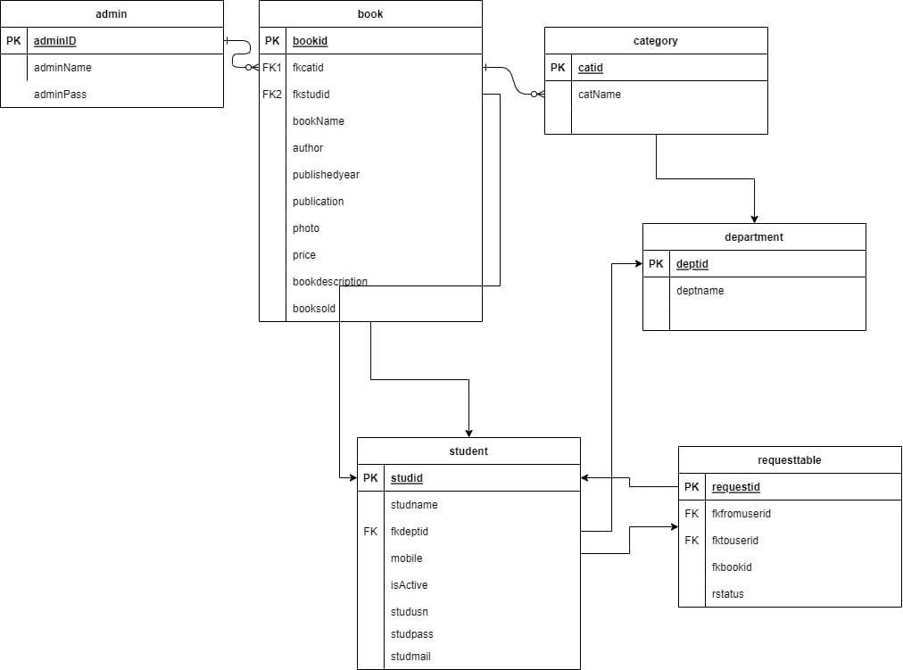

**Fig 4.1.1:** Entity Relationship

### DATA FLOW DIAGRAM

* + - The DFD is also called as bubble chart. It is a simple graphical formalism that can be used to represent a system in terms of input data to the system, various processing carried out on this data, and the output data is generated by this system.
    - The data flow diagram (DFD) is one of the most important modeling tools. It is used to model the system components. These components are the system process, the data used by the process, an external entity that interacts with the system and the information flows in the system. The figure in the Fig 4.2 represents the DFD of Used Book store .

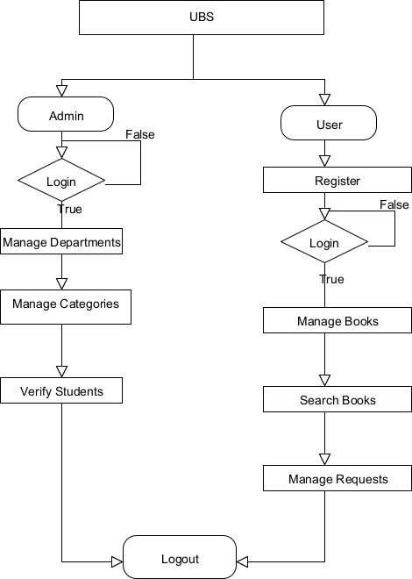

**Fig 4.3.1:** Data Flow Diagram

* + - DFD shows how the information moves through the system and how it is modified by a series of transformations. It is a graphical technique that depicts information flow and the transformations that are applied as data moves from input to output.
    - DFD is also known as bubble chart. A DFD may be used to represent a system at any level of abstraction. DFD may be partitioned into levels that represent increasing information flow and functional detail.

## CHAPTER 5

**SYSTEM IMPLEMENTATION**

### Tools and Technologies Used

#### PHP

Hypertext Pre-processor (or simply PHP) is a general-purpose programming language originally designed for web development. It was originally created by Rasmus Lerdorf in 1994 the PHP reference implementation is now produced by The PHP Group. PHP originally stood for Personal Home Page, but it now stands for the recursive initialism PHP: Hypertext Pre- processor.

PHP code may be executed with a command line interface (CLI), embedded into HTML code, or used in combination with various web template systems, web content management systems, and web frameworks. PHP code is usually processed by a PHP interpreter implemented as a module in a web server or as a Common Gateway Interface (CGI) executable. The web server outputs the results of the interpreted and executed PHP code, which may be any type of data, such as generated HTML code or binary image data. PHP can be used for many programming tasks outside of the web context, such as standalone graphical applications and robotic drone control.

#### MySql

MySQL is written in C and C++. Its SQL parser is written in yacc, but it uses a home- brewed lexical analyzer. MySQL works on many system platforms, including AIX, BSDi, FreeBSD, HP-UX, eComStation, i5/OS, IRIX, Linux, macOS, Microsoft Windows, NetBSD, Novell NetWare, OpenBSD, OpenSolaris, OS/2 Warp, QNX, Oracle Solaris, Symbian, SunOS, SCO OpenServer, SCO UnixWare, Sanos and Tru64. A port of MySQL to OpenVMS also exists. The MySQL server software itself and the client libraries use dual-licensing distribution.

#### XAMPP

XAMPP is a free and open-source cross-platform web server solution stack package developed by Apache Friends, consisting mainly of the Apache HTTP Server, MariaDB database, and interpreters for scripts written in the PHP and Perl programming languages. Since most actual web server deployments use the same components as XAMPP, it makes transitioning from a local test server to a live server possible. XAMPP's ease of deployment means a WAMP or LAMP stack

can be installed quickly and simply on an operating system by a developer. With the advantage a number of common add-in applications such as WordPress and Joomla! can also be installed with similar ease using Bitnami.

#### HTML

HTML stands for Hyper Text Markup Language. It is used to design web pages using markup language. HTML is the combination of Hypertext and Markup language. Hypertext defines the link between the web pages. Markup language is used to define the text document within tag which defines the structure of web pages. HTML 5 is the fifth and current version of HTML. It has improved the markup available for documents and has introduced application programming interfaces (API) and Document Object Model (DOM).

#### CSS3

CSS stands for Cascading Style Sheets. CSS is a standard style sheet language used for describing the presentation (i.e. the layout and formatting) of the web pages. Prior to CSS, nearly all of the presentational attributes of HTML documents were contained within the HTML markup (specifically inside the HTML tags); all the font colors, background styles, element alignments, borders and sizes had to be explicitly described within the HTML As a result, development of the large websites became a long and expensive process, since the style information were repeatedly added to every single page of the website

To solve this problem CSS was introduced in 1996 by the World Wide Web Consortium (W3C), which also maintains its standard. CSS was designed to enable the separation of presentation and content. Now web designers can move the formatting information of the web pages to a separate style sheet which results in considerably simpler HTML markup, and better maintainability.

CSS3 is the latest version of the CSS specification. CSS3 adds several new styling features and improvements to enhance the web presentation capabilities.

### Pseudo code

#### View Category

<!DOCTYPE html>

<html lang="en">

<?php

include('dbconfig.php'); include("head.php");

?>

<body>

<?php include("AdminHeader.php");

?>

<main id="content">

<div class="mb-5">

<img class="img-fluid" src="assets/img/login-bg.jpg" alt="Image-Description">

<div class="container">

<div class="mb-lg-8">

<div class="col-lg-9 mx-auto">

<div class="bg-white mt-n10 mt-md-n13 pt-5 pt-lg-7 px-3 px-md-5 pl-xl-10 pr-

xl-4">

<div class="mb-4 mb-lg-7 ml-xl-4">

<a href="AddCat.php" class="btn btn-danger float-right">Add Category</a>

<h6 class="font-weight medium font-size-10 mb-4 mb-lg-7 text-

center">View Category</h6>

</div>

<div id="signup" style="opacity: 1;" data-target-group="idForm" class="animated fadeIn">

<div class="p-4 p-md-6">

<table class="table table-striped table-bordered">

<thead>

<tr>

<th>Category Name</th>

<th>Action</th>

</tr>

</thead>

<tbody>

<?php

$selectsql = "select * from category";

$myselectsql = mysqli_query($con, $selectsql);

while ($row = mysqli_fetch_array($myselectsql)) {

echo "<tr>";

echo "<td> ".$row['catName']."</td>"; echo "<td>

<a class='btn btn-sm btn-info' href=ecat.php?catid={$row['catid']}><i class='fas fa- edit'></i></a>

<a class='btn btn-sm btn-danger' href=dcat.php?catid={$row['catid']}><i class='fas fa- trash'></i></a>

</td> ";

echo "</tr>";

}

?>

</tbody>

</table>

</div>

</div>

</div>

</div>

</div>

</div>

</div>

</main>

<?php include("footer.php"); include("script.php");

?>

</body>

</html>

#### View Department

<!DOCTYPE html>

<html lang="en">

<?php include('dbconfig.php'); include("head.php");

?>

<body>

<?php include("AdminHeader.php");

?>

<main id="content">

<div class="mb-5">

<img class="img-fluid" src="assets/img/login-bg.jpg" alt="Image-Description">

<div class="container">

<div class="mb-lg-8">

<div class="col-lg-9 mx-auto">

<div class="bg-white mt-n10 mt-md-n13 pt-5 pt-lg-7 px-3 px-md-5 pl-xl-10 pr-

xl-4">

Department</a>

<div class="mb-4 mb-lg-7 ml-xl-4">

<a href="AddDepartment.php" class="btn btn-danger float-right">Add

<h6 class="font-weight medium font-size-10 mb-4 mb-lg-7 text-

center">View Department</h6>

</div>

<div id="signup" style="opacity: 1;" data-target-group="idForm" class="animated fadeIn">

<div class="p-4 p-md-6">

<table class="table table-striped table-bordered">

<thead>

<tr>

<th>Department Name</th>

<th>Action</th>

</tr>

</thead>

<tbody>

<?php

$selectsql = "select * from department";

$myselectsql = mysqli_query($con, $selectsql);

while ($row = mysqli_fetch_array($myselectsql)) {

echo "<tr>";

echo "<td> ".$row['deptname']."</td>"; echo "<td>

<a class='btn btn-sm btn-info' href=edept.php?deptid={$row['deptid']}><i class='fas fa- edit'></i></a>

<a class='btn btn-sm btn-danger' href=ddept.php?deptid={$row['deptid']}><i class='fas fa- trash'></i></a>

</td> ";

echo "</tr>";

}

?>

</tbody>

</table>

</div>

</div>

</div>

</div>

</div>

</div>

</div>

</main>

<?php include("footer.php"); include("script.php");

?>

</body>

</html>

## CHAPTER 6

**SNAPSHOTS**

### OUTPUT:

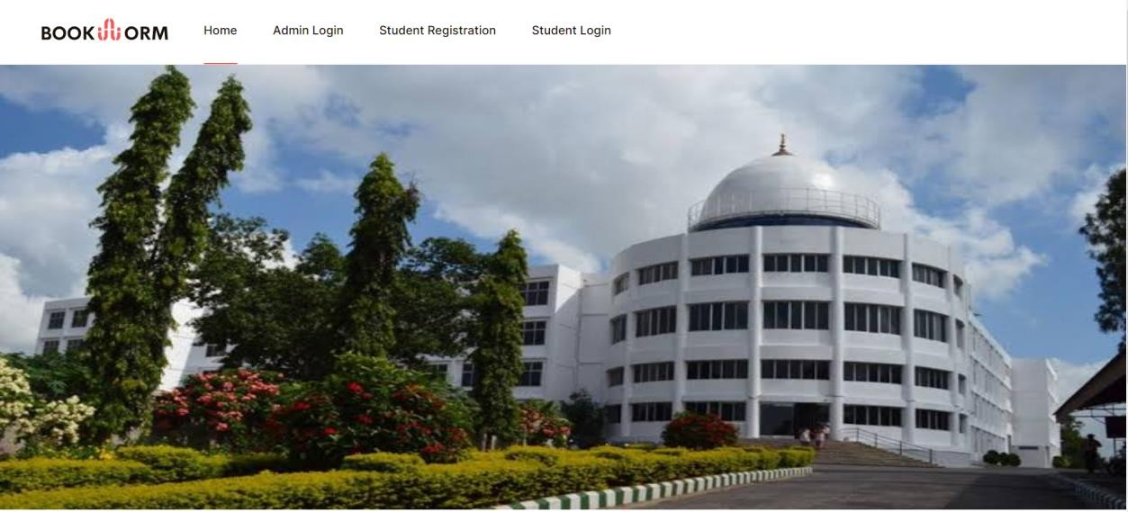

**Fig 6.1 :** Home Page

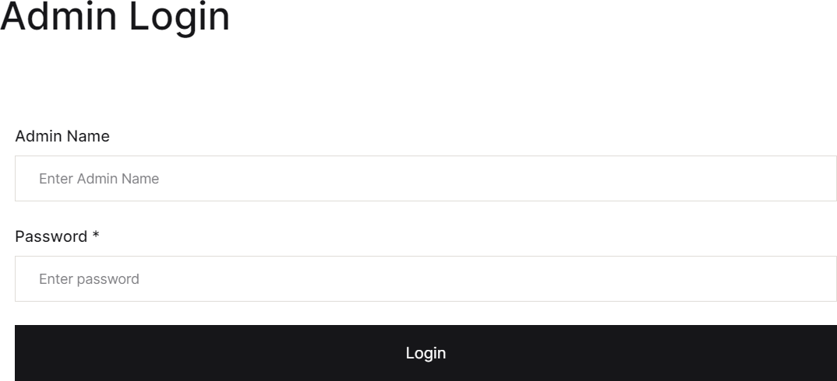

**Fig 6.2 :** Admin Login

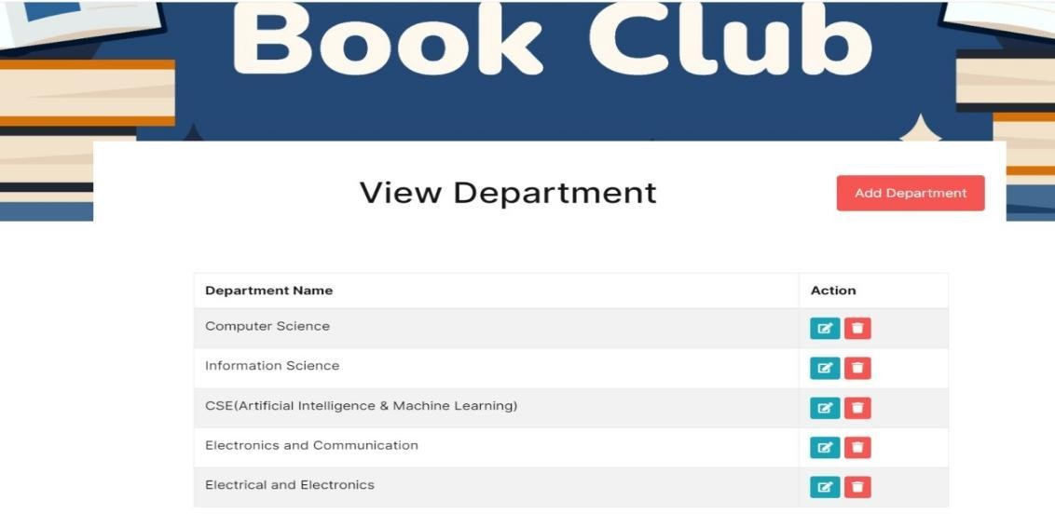

**Fig 6.3 :** View Department

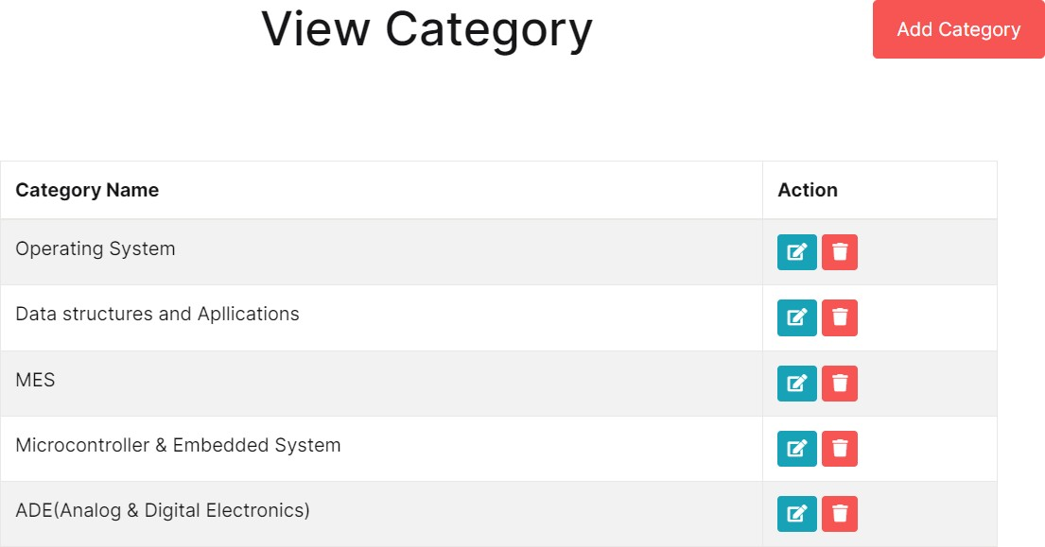

**Fig 6.4 :** View Category

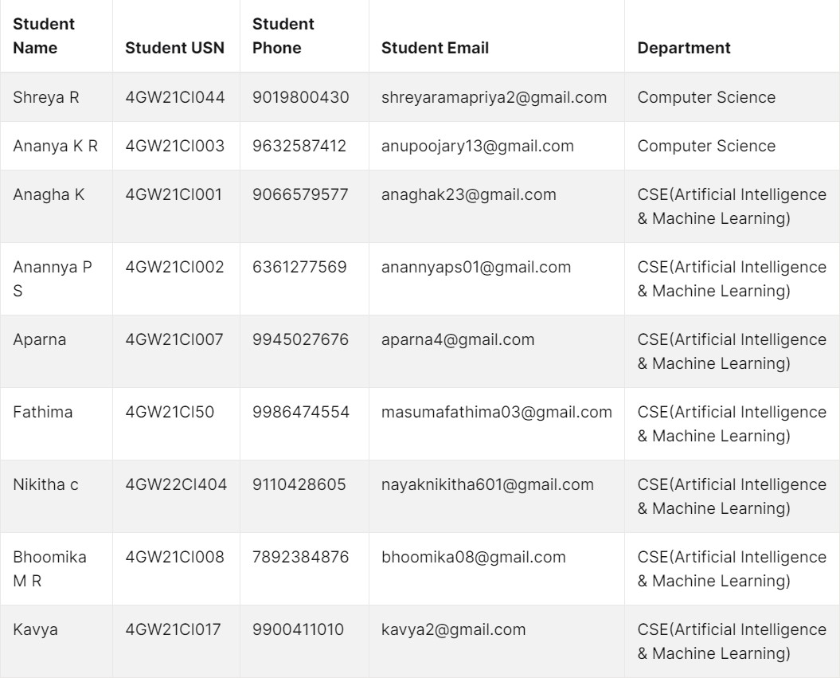

**Fig 6.5 :** Student list

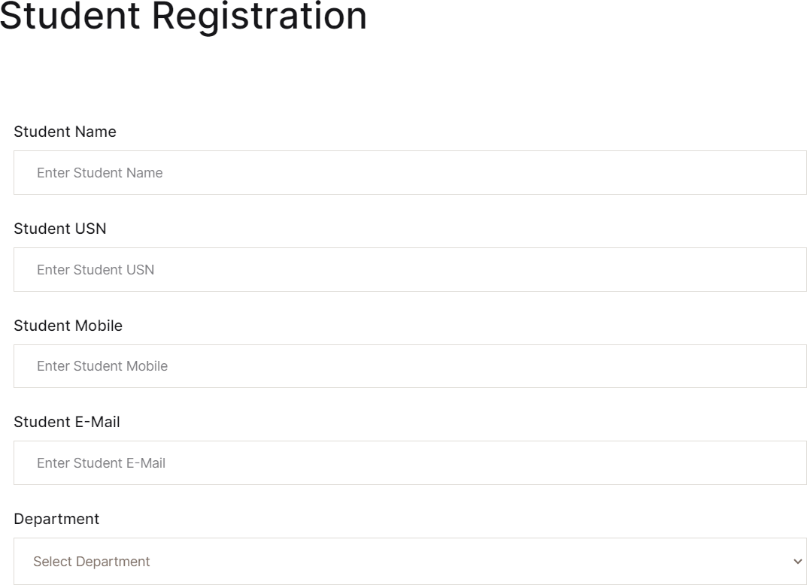

**Fig 6.6 :** Registration

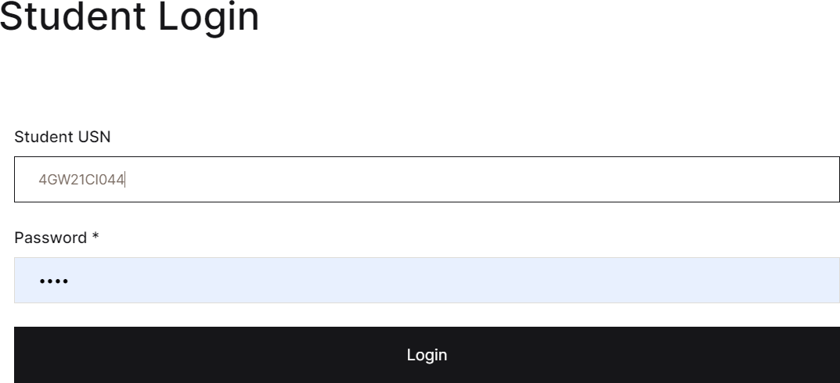

**Fig 6.7 :** Login page

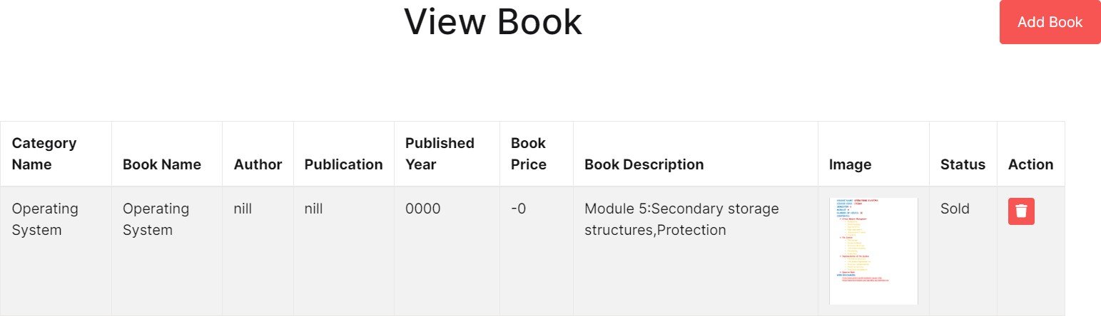

**Fig 6.8 :**View Books

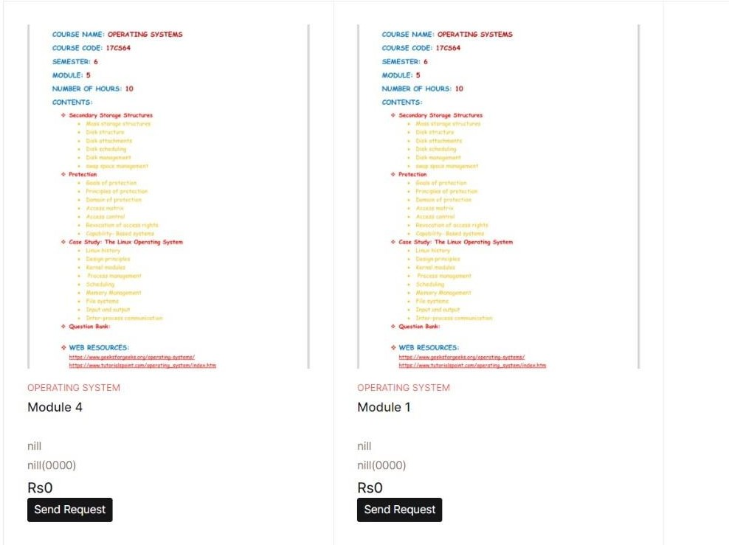

**Fig 6.9 :** Request Page

## CONCLUSION

System developed has been tested with sample data along with verification and validation of all the fields on the respective screens. These modules can be further changed for enhanced features without any major difficulty Suggestions for improvements and both positive and negative comments are always welcome.

GSSS Book Buddies has the potential to significantly improve the affordability and accessibility of course materials for students at GSSS College. By facilitating a streamlined and efficient second-hand book exchange platform, the application can promote cost savings, sustainability, and a stronger sense of community within the student body.

## FUTURE ENHANCEMENT

In future we can improve this project by adding more complexity and we can make this as a mobile application.One potential enhancement for a used book store application could be implementing a recommendation system based on user preferences and browsing history.This could help users discover new books they might be interested in purchasing.Additionally, integrating a feature that allow users to easily sell or exchange their own used books through the app could enhance its value and user engagement.

## LEARNING OUTCOMES

Engaging with Used Book Store Application project has offered valuable learning opportunities it help us to understand HTML,CSS and Javascript essentials for creating static and dynamic web pages.We gain proficiency in software development by applying programming languages, frameworks, and tools to create a functional and user-friendly application.We can understand the principles of UX design to create intuitive interfaces, enhancing user satisfaction and engagement.We learnt to design and implement databases to store and manage books, user information, and transaction records efficiently.Developed algorithms to facilitate book serach, recommendation, and personalized suggestions based on user preferences and browsing history.Implemented security measures such as encryption, authentication, and authorization to protect user data and transactions from potential threats.Gained experience in testing methodologies including unit testing, and user acceptance testing, to ensure the reliability and quality of the application.

## APPENDIX-I APPLICATION INSTRUCTIONS

### Procedure to use our application

To use our application, follow these steps:

**STEP 1:** Access the portal by using the URL <http://usedbookstore.great-site.net/index.php>

**STEP 2:** Registration: If you’re a new user, you’ll need to register by providing basic information such as your email address, USN and password.

**STEP 3:** Login: Once you’ve registered, log in using your credentials.

**STEP 4:** Navigate to the Manage Book Section: Once logged in, navigate to the book section where you will able to add the new books by providing book name,book author, and book publication.

**STEP 5:** The books added in the previous step will be displayed in view book section.

**STEP 6:** Navigate to the Search Book List: Once logged in, navigate to the book list section where you will be able to search the uploaded books based on categories.

**STEP 7:** View My Request: The students can send request regarding notes to the concerned owner which can be viewed through view my request which acts like a wishlist.

**STEP 8:** View Others Request: Additionally, When a student request a book, the request will be sent to the concerned owner which can be checked through view others request section.

## REFERENCES

1. Nicole Spector (2018, Aug 22). Textbooks are expensive. Here are some ways to cut down on the cost.

https:/[/www](http://www.nbcnews.com/better/business/textbooks-are-expensive-here-are-some-ways-cut-).[nbcnews.com/better/business/textbooks-are-expensive-here-are-some-ways-cut-](http://www.nbcnews.com/better/business/textbooks-are-expensive-here-are-some-ways-cut-) down-cost-ncna902161

1. Robert Farrington (2019, August 22). How To Combat The Rising Cost Of College Textbooks

https:/[/www](http://www.forbes.com/sites/robertfarrington/2019/08/22/how-to-combat-the-rising-cost-of-).[forbes.com/sites/robertfarrington/2019/08/22/how-to-combat-the-rising-cost-of-](http://www.forbes.com/sites/robertfarrington/2019/08/22/how-to-combat-the-rising-cost-of-) college-textbooks/#76684c59798b

1. Caleb Roth (2018, Dec 10). Textbook Pricing Strategies – Fall Edition https:/[/www](http://www.thebookflipper.com/post/textbook-pricing-strategies-fall-edition).[thebookflipper.com/post/textbook-pricing-strategies-fall-edition](http://www.thebookflipper.com/post/textbook-pricing-strategies-fall-edition)
2. Fatin Najwa Binti Abdullah Sani (2017, June 03) e-Bookstore: Opening Door to the Garden of Knowledge

<http://www.ijsrp.org/research-paper-0617.php?rp=P666520>

1. David Weedmark (2011, Oct 26). https://smallbusiness.chron.com/blog-sell-books-32541.html